Forms Authentication Demo Steps

Step 1: create a database (MVC_DB)

Create tables such as Users,Employee, RoleMaster, UserRoleMapping

CREATE TABLE [dbo].[Employee](

[ID] [int] IDENTITY(1,1) NOT NULL,

[Name] [varchar](50) NULL,

[Designation] [varchar](50) NULL,

[Salary] [int] NULL,

PRIMARY KEY CLUSTERED

(

[ID] ASC

)WITH (PAD_INDEX = OFF, STATISTICS_NORECOMPUTE = OFF, IGNORE_DUP_KEY = OFF, ALLOW_ROW_LOCKS = ON, ALLOW_PAGE_LOCKS = ON) ON [PRIMARY]

) ON [PRIMARY]

GO

USE [MVC_DB]

GO

/****** Object: Table [dbo].[Users] Script Date: 06-04-2022 11:29:33 ******/

SET ANSI_NULLS ON

GO

SET QUOTED_IDENTIFIER ON

GO

CREATE TABLE [dbo].[Users](

[ID] [int] IDENTITY(1,1) NOT NULL,

[UserName] [varchar](50) NULL,

[UserPassword] [varchar](50) NULL,

PRIMARY KEY CLUSTERED

(

[ID] ASC

)WITH (PAD_INDEX = OFF, STATISTICS_NORECOMPUTE = OFF, IGNORE_DUP_KEY = OFF, ALLOW_ROW_LOCKS = ON, ALLOW_PAGE_LOCKS = ON) ON [PRIMARY]

) ON [PRIMARY]

GO

USE [MVC_DB]

GO

/****** Object: Table [dbo].[RoleMaster] Script Date: 06-04-2022 11:30:00 ******/

SET ANSI_NULLS ON

GO

SET QUOTED_IDENTIFIER ON

GO

CREATE TABLE [dbo].[RoleMaster](

[ID] [int] IDENTITY(1,1) NOT NULL,

[RollName] [varchar](50) NULL,

PRIMARY KEY CLUSTERED

(

[ID] ASC

)WITH (PAD_INDEX = OFF, STATISTICS_NORECOMPUTE = OFF, IGNORE_DUP_KEY = OFF, ALLOW_ROW_LOCKS = ON, ALLOW_PAGE_LOCKS = ON) ON [PRIMARY]

) ON [PRIMARY]

GO

USE [MVC_DB]

GO

/****** Object: Table [dbo].[RoleMaster] Script Date: 06-04-2022 11:30:00 ******/

SET ANSI_NULLS ON

GO

SET QUOTED_IDENTIFIER ON

GO

CREATE TABLE [dbo].[RoleMaster](

[ID] [int] IDENTITY(1,1) NOT NULL,

[RollName] [varchar](50) NULL,

PRIMARY KEY CLUSTERED

(

[ID] ASC

)WITH (PAD_INDEX = OFF, STATISTICS_NORECOMPUTE = OFF, IGNORE_DUP_KEY = OFF, ALLOW_ROW_LOCKS = ON, ALLOW_PAGE_LOCKS = ON) ON [PRIMARY]

) ON [PRIMARY]

GO

Create Asp.Net MVc Project

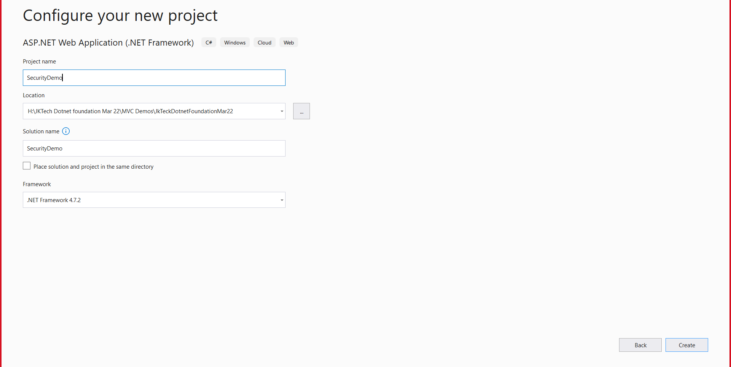

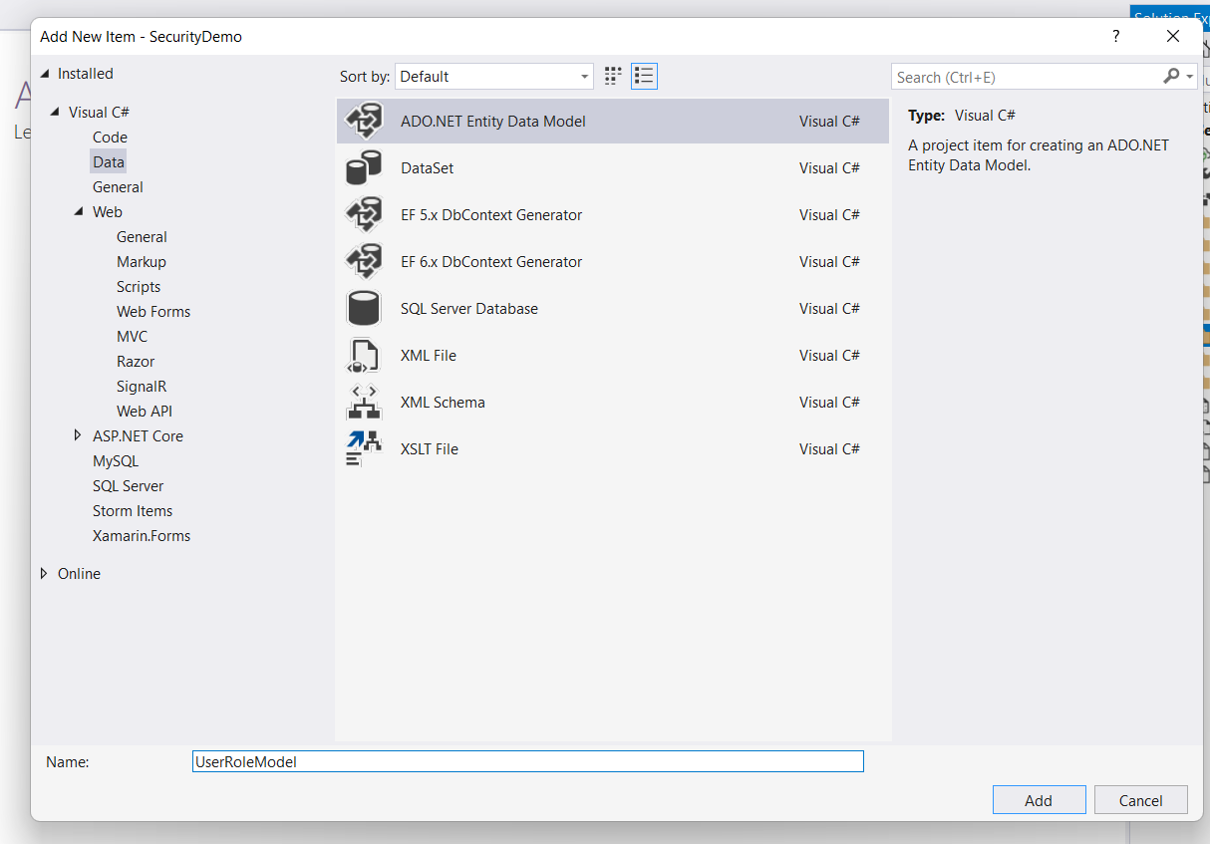

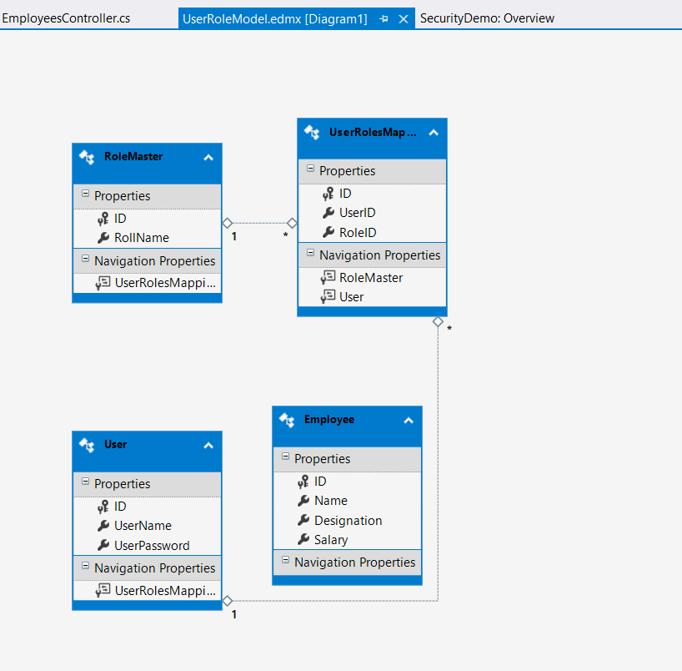

Add controller using EF for Employee class.

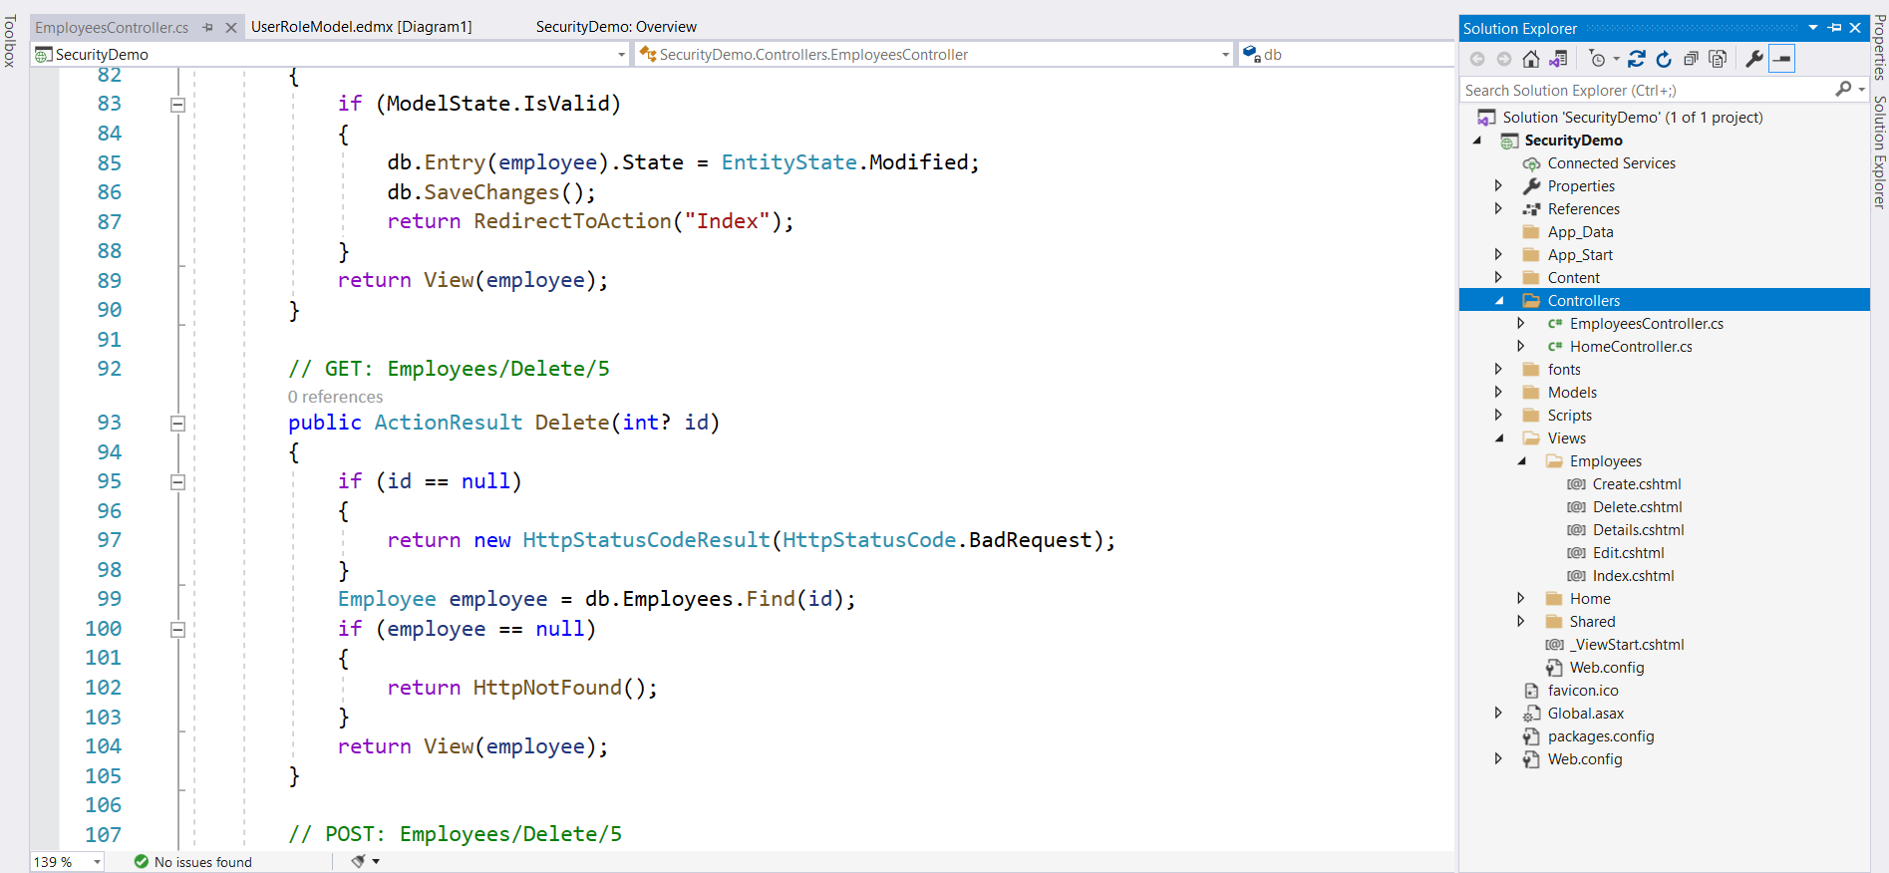

Right click on Models folder 🡺 add New Class (UserModel)

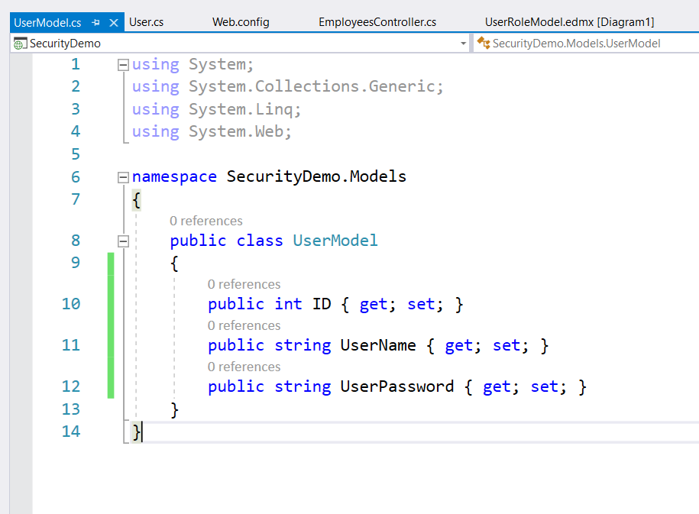

Right Click on Controllers🡺 Add New Controller (Empty) 🡺 AccountsController

Rename Index action Method to Login🡺 add view

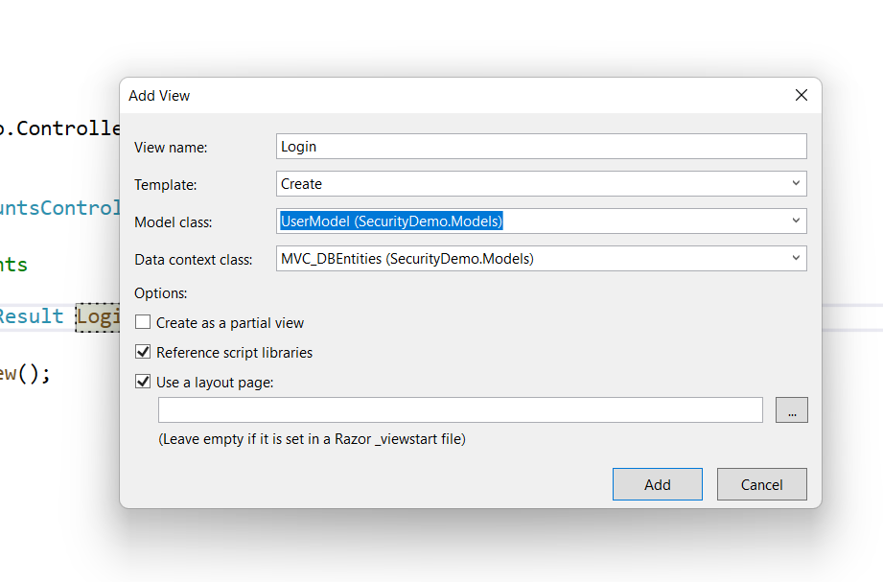

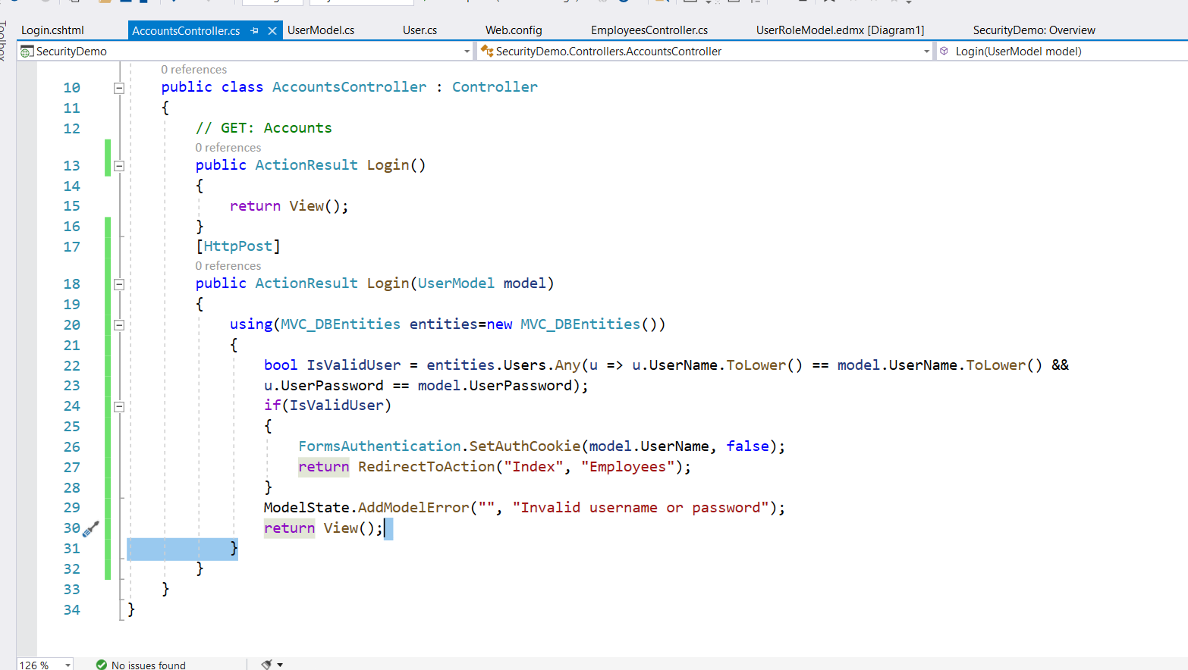

Goto web.config file

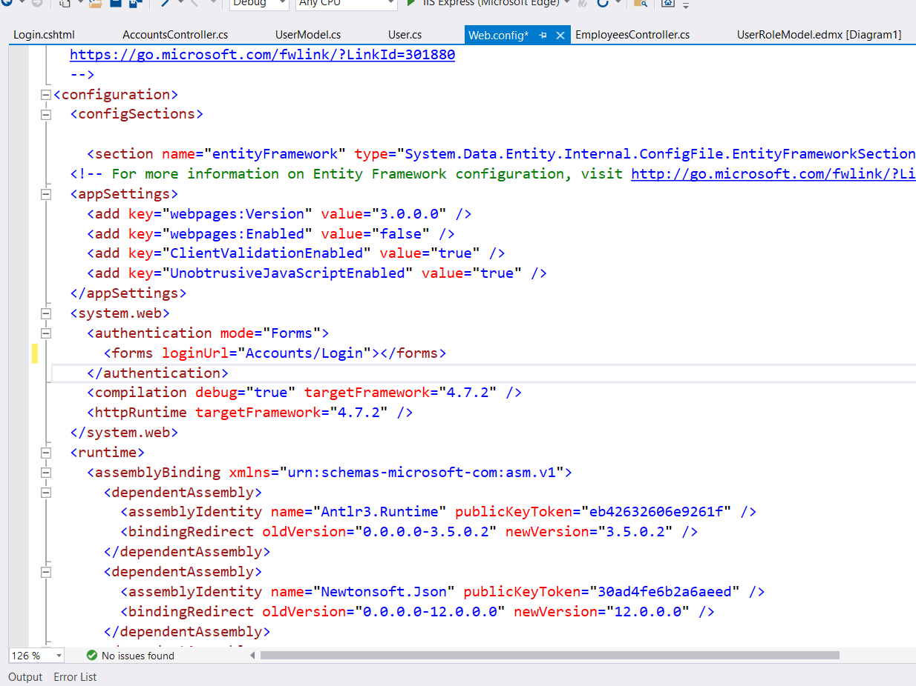

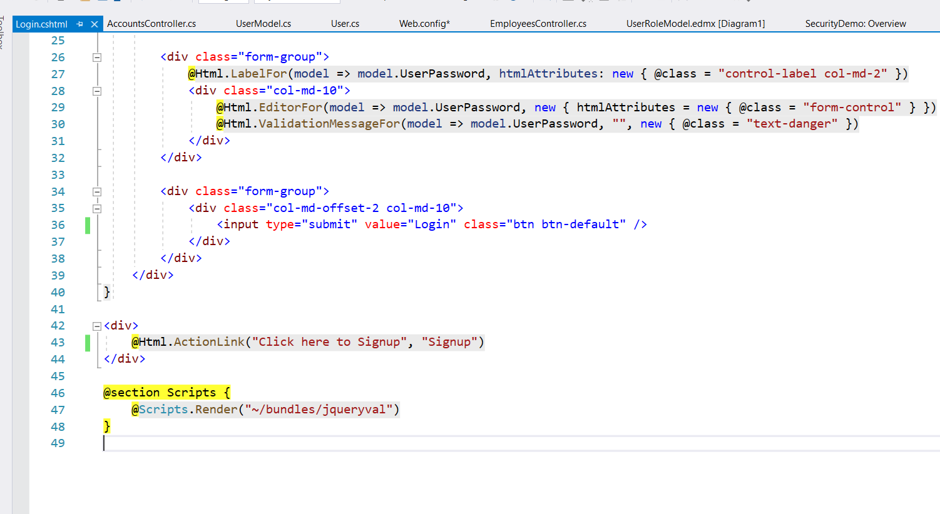

Goto Accounts Controller 🡺 implement Signup

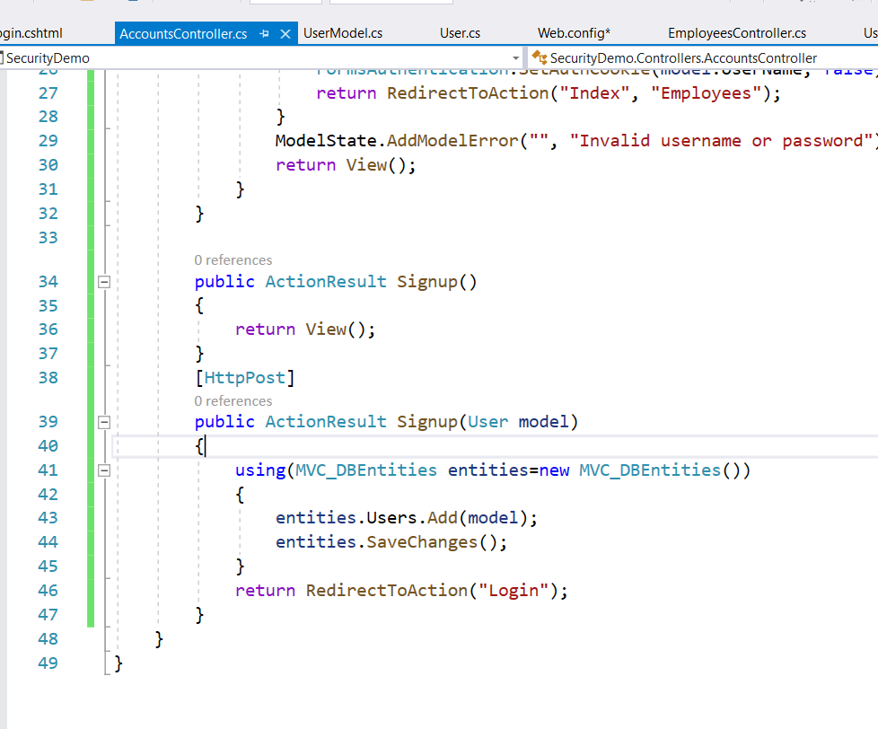

Add View for Signup 🡺

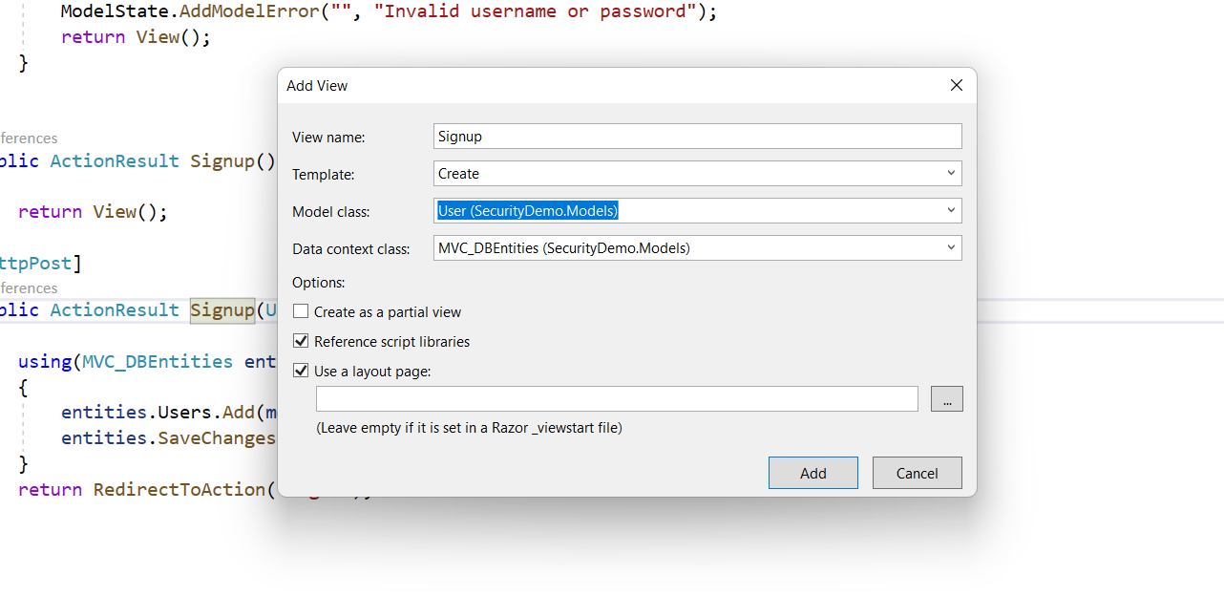

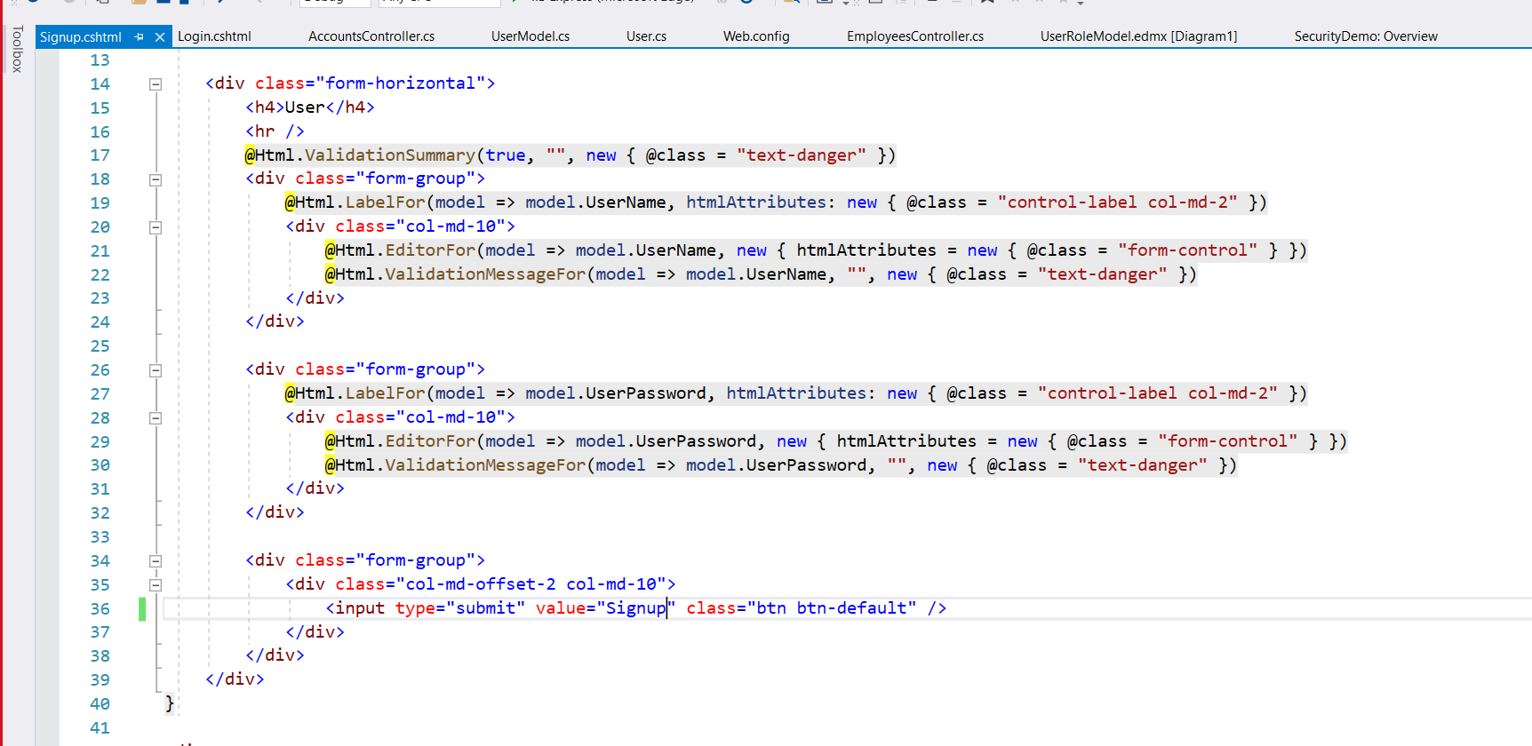

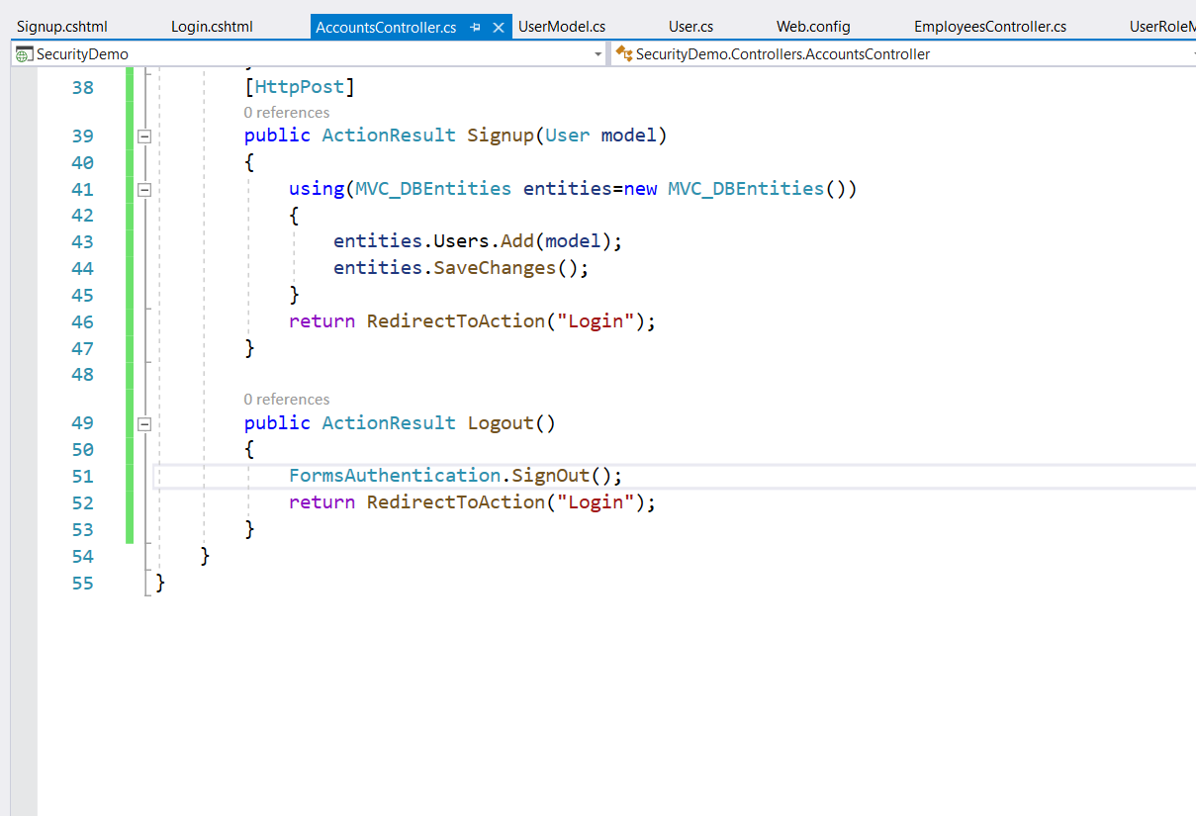

Goto views🡺Shared🡺 layout.cshtml

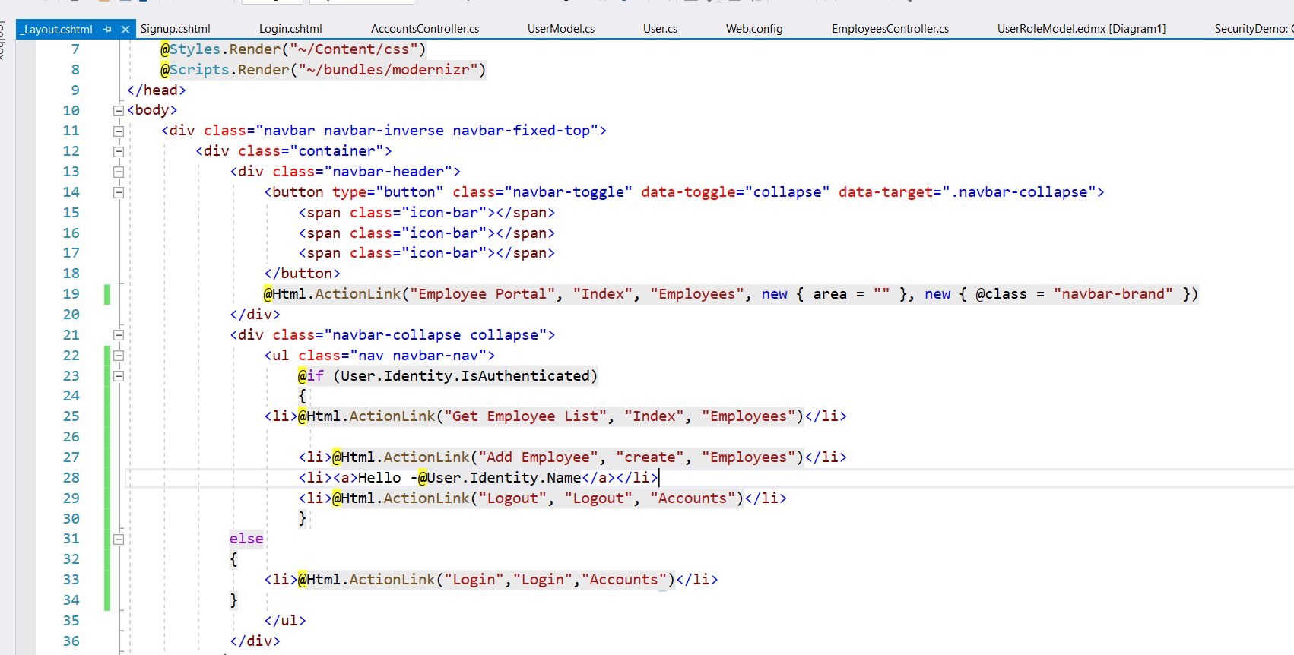

Run the application.

Application is redirecting all views of Employee controller. But it should not visible without login (or) invalid users.

Goto Employees controller add Authorize Attribute

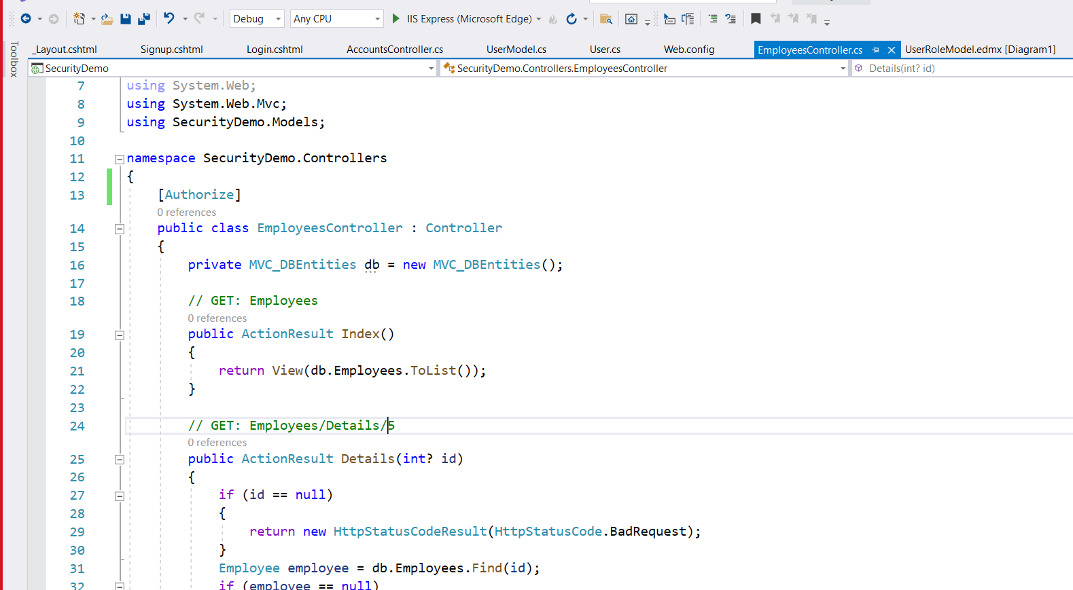

Run the Application .It will work as we expect.